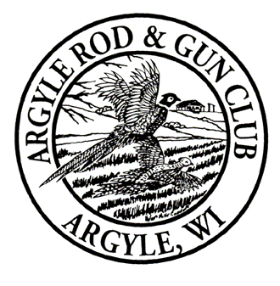
30th Annual Argyle Rod & Gun Club _{Inc.} Sportsman’s Banquet
Tuesday, January 30, 2024
Ludlow Mansion, 417 Mansion Dr., Monroe, Wisconsin
(Doors will open to ticket holders at 5:30 p.m., with dinner starting at 6:00 p.m.)

Tickets are now available for the 30th annual ARGC _{Inc}. Sportsman’s Banquet on a first-come, first-served basis. Numbers are limited, so there is no guarantee that tickets will be available at the door. Please send your ticket application in early to ensure you get one! Tickets for applications post marked before January 8TH, 2024 will be mailed to you. Tickets for applications received after the 8th will be available at the door. You will be notified if tickets are no longer available for your application.

Yearly membership is $40 for 2024. The regular ticket price is $70.00 each, which includes dinner and one regular yearly membership. Regular ticket holders are also included in the member prize drawing. Spouse tickets and Youth tickets are $40 but do not include a regular yearly membership. Spouse and youth who wish to purchase a regular ticket ($70) may do so, but then are eligible for the regular member prizes, become a regular member and are not eligible for youth and spouse prizes. Life Members purchasing a regular ticket will receive a voucher for raffle entry equivalent to the yearly membership. The ticket application, also contains a Grand Raffle flier. You may purchase Grand Raffle tickets along with your Banquet tickets. (Grand Raffle Tickets are not mailed and will be available for review at the
Banquet.) Regular Tickets include a membership, if you are not buying a Regular Ticket, you may also renew your Yearly Membership using the ticket application form.

Please note this important message! Regular, Spouse, and Youth Banquet ticket holders, you must be present to win Banquet prizes. A prize will not be given out to a family member, friend, or anyone else. If you are unable to attend and someone uses your ticket, the agreement between you and the individual going to the banquet is of a private nature. ARGC _{Inc}. assumes no responsibility for prize distribution and the prize will be given to the individual attending the banquet. This does not apply to the Grand Raffle; you need not be present to win; prizes go to the ticket owner. Also, you may not purchase more than one regular ticket per person, only one ticket per person for the member prize drawing.

We look forward to seeing you at our 30th Annual Sportsman’s Banquet. There will be additional raffles with guns on them, the gun safe will include a mystery gun inside.

Please visit our web site at argylegunclub.com for more ARGC _{Inc}. information. Also, for all members: Don’t forget to come to the Annual Meeting on Saturday, February 24th at the Club. You can help elect board members and participate in governance of ARGC _{Inc}.
ARGC _{Inc}. thanks you in advance for helping make our banquet such a success.

Sincerely,

Lance Flannery, President, ARGC _{Inc.}

