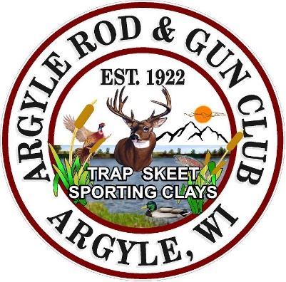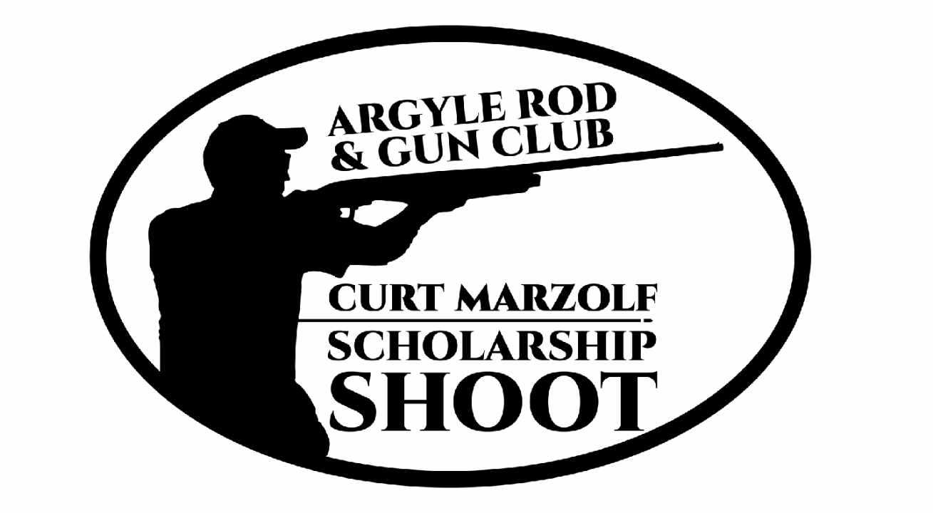
Curt Marzolf Scholarship Shoot
Sponsorship Form
100% of donations go to scholarships for High School graduates from local schools who participate in organized Shooting Sports (WIAA, FFA, 4-H, etc.). Next awards will begin in Spring of ’27.
Please complete this form fully.
Name / Company Name: _______________________________________________________
Address: ____________________________________________________________________
Contact: ____________________________________________________________________
Phone Number: _____________________ e-mail: ___________________________________
Logo link (if desired): ___________________________________________________________
Logo art link can also be emailed to the listed email. (For recognition at the shoot)
Level of Sponsorship
____ 12 Gauge - $500, ____20 Gauge - $250, ____28 Gauge - $100, ____.410 Bore - $50
Or, we are also seeking merchandise donations for prizes, silent auctions and raffles.
____ Raffle and Silent Auction Donation Item: ___________________________________
~~~~~~~~~~~~~~~~~~~~~~~Make Checks Payable to ARGC Scholarship Fund~~~~~~~~~~~~~~~~~~~~
Please mail completed forms to: ARGC, PO Box 221, Argyle WI, 53504 or e-mail images of them to secretary@argylegunclub.com.
For more information: Contact Harold Marzolf at 608-558-5807 or marzolfh@gmail.com.

